Ecclesfield Group Practice

Practice Leaflet

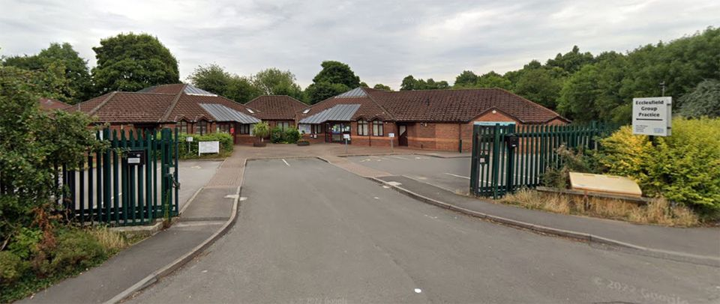

GP Partnership of:

Doctors Subasinghe, Sibson, Wagstaffe & Kaufman

Ecclesfield Group Practice
96a Mill Road, Ecclesfield, Sheffield S35 9XQ.
Tel: 0114 2469030
Email: syicb-sheffield.ecclesfieldgp@nhs.net

Margetson Surgery (Branch Site)
1 Remington Avenue, Parson Cross, Sheffield S5 9PA
Tel: Same as the Ecclesfield Number

For Home Visits - Tel 0114 246 9030
In an Emergency Ring – 0114 246 9030

Website Address: www.ecclesfieldgp.co.uk

Last Updated: January 2025
INTRODUCTION

Welcome to Ecclesfield Group Practice. This leaflet is for use by the patients and community served by our practice. It includes information about who we all are, the services we provide and outlines the standards we aim to achieve.

THE TEAM

GP Partners

Dr Mali Subasinghe GMC No: 6026893 MB. ChB. M.R.C.G.P. D.F.S.R.H
Dr Jessica Sibson GMC No: 6054553 MBChB M.R.C.G.P. M.R.C.P. D.F.S.R.H (DFFP) D.R.C.O.G
Dr Lucy Wagstaffe GMC No: 6159188
Dr Naomi Kaufman GMC No: 7149151

Salaried GPs

Dr Joanne Bennett GMC No: 6028014 BMBS, MRCP, MRCGP, DRCOG
Dr Ted Turner GMC No: 3288450
Dr Alice Howlett GMC No: 7456734 MBChB (Hons), MRCGP and PGDip MedEd
Dr Eleanor Coster GMC 7523481 MBChB RCGP
Dr Martin Billington

Practice Nurses & Health Associates

Kerry Newton Nurse Prescriber, ADNS, BMEDsci Nursing studies RGN Nurse Prescriber
Donna Bradbury Nurse Practitioner,
Catherine Kelsall Nurse Prescriber, RGN, Nurse Prescriber.
Claire Grierson Nurse Practitioner
Lesley Platts Nurse Practitioner
Anna Hind Phlebotomist
Yvonne Lindley HCA/phlebotomist

Management and Administration Team

Michelle Payling Practice Manager
Tracey Melluish Admin/Medical Secretary
Rachel Gill Admin/Medical Secretary
Gillian Hanby Clinical Admin Co-ordinator
Jayne Wilkinson Clinical Admin Co-ordinator

The Reception Team Senior Reception Team: Andrea & Emma
Receptionists & Additional Administration staff: Louise, Georgia, Lauren, Beverley, Tessa, Cassy, Sarah, Stephanie, Jade & Claire

SURGERY OPENING TIMES

Ecclesfield Surgery |  | Margetson Surgery
Monday | 8:30am to 6.30pm | Monday | 8:30am to 5:00pm
Tuesday | 8:30am to 6.30pm | Tuesday | 8:30am to 1.00pm
Wednesday | 8:30am to 6.30pm | Wednesday | 8:30am to 5:00pm
Thursday | 8:30am to 2.30pm | Thursday | 8:30am to 1:00pm
Friday | 8:30am to 6.00pm | Friday | 8:30am to 5:00pm
Well Baby Clinic – Wednesday 1.00 to 3.00 (by appointment only)

Please note we do not answer the telephones during the period of 1-2pm on a Monday, Tuesday, Wednesday, and Friday and after 12 noon on Thursday.

ONLINE SERVICES - From the date of registration all over 18’s will automatically be registered for online services, i.e. Online appointment booking, requesting repeat prescriptions and access to your own health record. ID logins and Passwords will be sent to your in due course.

APPOINTMENTS

The practice offers a variety of ways in which you can get an appointment to see one of our clinicians. We try to maintain a balance between pre-bookable appointments, whilst still allowing capacity to see patients who are unwell and need to be seen that day. An appointment is for one person only. Please let us know at the time of booking if more than one person needs to be seen. If your problem is complex or you feel you need extra time, please ask for a double appointment.

We have asked our receptionists to ask you a little bit about your problem to help us direct you to the best person.

Nurse Clinics
Our nurse practitioners hold some minor ailment clinics and can deal with many day-to-day ailments. You may therefore be asked whether an appointment with the nurse would be appropriate. Our nurses also run specialist clinics for the monitoring and management of chronic diseases, such as Diabetes, Heart Disease, Blood Pressure, Asthma and COPD. Please ask for details at reception.

Enhanced Hours - This service is for all patients of the practice but will be for pre-booked appointments ONLY aimed at those patients who are unable to attend at other times of the week, perhaps due to work commitments, or if they need a carer to bring them to surgery. This extended opening IS NOT an emergency service and requests for urgent appointments will still need to be accessed through our GP Collaborative Out-of-Hour’s provider.
Requests for home visits should also be made in the usual way for Out-of-Hour’s care.
Book on the day appointments.
.
We offer a number of appointments to book on the day you wish to be seen. Please ring after 8.30am to request one of these.

There are times when all the available appointments have been taken on a given day. If you feel your condition is urgent and you need to be seen that day the receptionist may ask for certain details to discuss with the doctor. The doctor may phone you back directly or arrange for you to be seen as an extra during that day’s surgery sessions. At busy times this may mean a wait in the surgery, but you will be seen as soon as we are able.

Consultations take place during the following times:-

Morning Sessions: 8.45am – 11.45am
Afternoon Sessions 3.15pm – 5.45pm (except Thursdays)

We aim to see you within 20 minutes of your appointment time but please remember that unexpected emergencies may take the doctor away from his surgery and you will be waiting longer for your appointment. These are unavoidable and we ask you to be patient - one day you may need an emergency service. We will try to keep you informed of any such delays.

If you have booked an appointment which you no longer need, please tell us as soon as possible. This allows us to offer the appointment to another patient. If you simply do not turn up, that appointment is wasted. If you do this regularly, we will warn you by letter and if you continue to abuse the service in this way, we may ask for you to be removed from our list.
The receptionists are here to help you. They have a difficult and challenging job so please show the staff the respect they deserve and work with them to arrange the best possible solution. We may not always be able to offer you an appointment at your convenience, but we will always try our best to get you seen.

If you require general health advice you can obtain this from your local pharmacist or by calling the National 111 Health Advice Line or Online at www.nhs.uk. If you want test results or other non-urgent enquiries, then please contact us after 11am.

Our Nurse Practitioners also run daily Minor Illness Clinics and can deal with many medical problems such as chest, urine, and other infections.

HOME VISITS

Home visits are provided for housebound or seriously ill patients only. We are unable to provide visits for social reasons like lack of transport or because there is not an appointment for the exact time or day you want it. Please ask friends or relatives to bring you to surgery if you do not have transport or consider using the bus or a taxi before asking for a visit. A doctor can see around four people in surgery in the time they do one visit. Also, more thorough examinations can be done in the surgery than at home using surgery-based equipment and facilities. Visit requests should be made before 10.30am so that the doctors can organise their visits efficiently. We will try our best to be flexible but do have limited resources.

If a visit is genuinely needed, then we will aim to respond as follows:

Emergencies within the hour
Same day within 3 hours after the end of surgery
Routine or follow up within one week.

EMERGENCY OUT OF HOURS ADVICE AND VISITS

The Sheffield GP Collaborative cover at all times when the surgery is closed.

The number to ring is: 0114 246 9030 - Ecclesfield Surgery
0114 246 9030 - Margetson Surgery

(Your call will be automatically transferred to the out of hour’s service.)

Please have the following details to hand when calling for a visit or the out of hours services

* Name and age of patient
* Address of which they are staying
* Contact Number

The GP Collaborative will either give you advice over the telephone, ask you to go to their emergency surgery or, in exceptional circumstances they will visit your home.

WE GET A LOT OF UNNECESSARY REQUESTS FOR HOME
VISITS, PLEASE THINK CAREFULLY BEFORE REQUESTING ONE

TELEPHONE SERVICE

The telephones are answered by the reception team during surgery hours, and they will be able to offer you help and advice throughout the day.

Non-Urgent Queries – For all other non-urgent queries, including results please telephone after 2.00 pm.

Surgeries and telephones are at their busiest in the mornings so for all non-urgent requests or complicated enquires we ask that you contact us after lunch. This way, we will have more time to deal efficiently with your request. The doctors and nurses are also available at certain times of the day. You may be asked to call back, or your details can be taken so that the doctor can call you back later. If your call is an emergency, please tell the receptionist who will respond accordingly.

Text Messaging – We offer a text messaging service whereby we will send you reminders of any appointments you may have. At times we may also send results from some tests via this service.

REPEAT PRESCRIPTIONS

We ask you give us at least 2 working days’ notice if you collect your prescription and 5 working days if you have your prescription delivered. Home delivery services are available from a number of local pharmacies. You will need to confirm with them if you are eligible for this service.

You can order repeat prescriptions by:

- Post (please enclose a stamped addressed envelope if you would like us to post it back to you)
- In person at the surgery, bring in the right side of the prescription and place this in our post box in the waiting area.
- Online Repeat Prescription Ordering – You will need to register for this service.

Please be clear about what you need when ordering and do not order anything you do not need. Keep the most recent copy of your prescription counter sheet so that you can refer to it the next time you need to order.

Sometimes, we need to check your items with a doctor. This can cause delays in preparing prescriptions. Similarly, you may need to be seen for a review before a prescription can be given - these procedures are for your own safety so please be patient if these occur.

Please take responsibility for your own medication by making sure you give us the right information and in plenty of time.

OTHER SERVICES PROVIDED AT THE PRACTICE

We provide the special clinics or have time set aside for the following:

Antenatal care
Aural care - for ear problems
Asthma Management
Blood tests and warfarin monitoring
Chiropody for diabetic patients by doctor’s referral only
Diabetes Management
Flu vaccination clinics in October and November each year.
Hypertension management
Women’s Health Reviews including Menopause.
Physiotherapy - by doctor’s referral only
Well baby clinics for advice and injections.
Child Health Surveillance
Well person for general screening – blood pressure, height, weight, cervical smear testing.
Contraception & Sexual Health
Contraception Injections (Nexplanon) (by referral only)
Emergency contraception - fully confidential service
Counsellor (by GP referral only)
Smoking Cessation Group
3 Yearly checks for 16–74-year-olds on request (All 16–74-year-olds ideally should have at least one medical within a 3-year period)
Elderly over 75 checks (All 75+ patients should ideally have an annual check and the practice will honour its obligation to promote this check)

Primary Care Additional Services

24hr ECG Fitting
24hr Blood Pressure
Soft Tissue and Joint injections

The District Nursing Team: The district nursing team provide clinics or home care depending on need for dressings, injections, continence supplies and palliative care.

The Health Visitor Team - Tel: 0114 305 3224 Their work is primarily with families with children under the age of five. The health visiting team run a number of community clinics. To find out when and where these clinics run, ring them on the above number.

Community Midwife Team - The practice offers a midwife service at Ecclesfield Surgery. This is for both Margetson and Ecclesfield patients.

Clinic Times: Tuesdays - 9.30am – 12.30pm (Ecclesfield Surgery)

GENERAL INFORMATION
Medical Records
Patients may request, in writing, access to their medical records but the original records may not be removed from the practice premises. Patients can also now access their medical record via the SystmOnline service. However, to access this you would need to register for online access, please contact our reception team for further information.

Private Fees
There are certain services that patients request which are not covered by the National Health Service, e.g., fitness to drive medicals and completion of private health insurance claim forms, for which we must charge. These are updated annually and listed in the practice.

Chaperones
We appreciate that some patients may feel more comfortable having a chaperone present during an examination by a doctor or nurse. If you would like to have someone else with you during an examination, please tell the receptionist when you arrange the appointment.

General Data Protection Regulation (GDPR)
We believe that any patient we are in currently in contact with via text messaging has given us formal consent to contact them about their appointments and healthcare information. We have this recorded in your clinical record.

However, we want to remind you of your rights to withdraw this consent at any time. If you believe you have not given us formal consent or wish to withdraw your consent for the practice to communicate with you in this way, please contact the practice reception team and we will remove you from this service.

Please remember that we rely on you keeping us up to date with your correct telephone contact information in order that we do not send messages to the incorrect number.

GDPR puts a greater onus on us to ensure that patients fully understand our policy for sharing health related information and your rights within this process. It is therefore important for us to reiterate to patients that the sharing of medical information is only provided in order to better improve your care. We will not share your medical information with any third-party provider of care should you not wish us to do so.

You can find on our website a list of documents informing you of how we manage your data and the processes our staff work to. Every employee of the NHS has a legal responsibility to treat patient records in the strictest confidence and access to your records is fully auditable.

We also believe it important that patients have full confidence in our working processes so if you have any concerns about GDPR and what this means for you, please contact the Practice Manager.

Facilities for the Disabled
There is access for wheelchairs to all surgeries and treatment rooms at both surgeries. We have automated doors for entrance at Ecclesfield.

Sickness Certificate
Under current legislation a patient ‘self-certificate’ is used for the 7 days. The self- certificate (form SC2) is available from your employer or the Post Office. After the first week, certificates may be obtained at consultation with your doctor. Some employers insist on sickness certificates lasting less than seven days. As this is not a statutory requirement, a charge will be made for issuing a certificate under seven days.

Violence and Abuse
A zero-tolerance policy towards violence, threatening and abusive behaviour is now in place throughout the National Health Service. The staff at the surgery have a right to carry out their work in an environment free from such behaviour and accordingly we take this right seriously. If you do not respect this right, we may choose to inform the police and/or make arrangements for your removal from our medical list.

Information about you
We ask for information about you to enable staff to provide you with relevant care and treatment, both within the surgery and the local NHS area. We keep this information so that it can be referred to during future consultations/treatment. This information may also be used for other reasons; other areas of the NHS may require information upon referral to secondary care, for data collection or research purposes. Wherever possible or relevant all patient identifying details are removed.

The NHS Central Register for England and Wales contains details of all patients registered with a GP, but this does not include clinical information. Under certain circumstances we are required by law to provide information, such as a birth. We may also need to share information about you with other healthcare workers who are providing care for you. Anyone receiving this information is under a legal duty to keep any information known about you confidential. Further information regarding access to patient details and your rights are available from the surgery.

Training & Education
The practice plays an important part in the training of medical students from Sheffield University. Students do sit in with our clinicians and on such occasions your consent for them to do this will be sought. If you do not wish for a student to be present your wishes will be honoured.

Contact Details
To keep our contact records up to date, please inform us regularly of any changes to your address /telephone number and/or next of kin details. Please ask at reception for a change of contact’s form. Please help us to help you.

Moving to a new house
Patients have a responsibility to inform us when they move to a new house. The practice has a right to remove (with notice) any patient who has moved outside the practice boundary, and we will inform you of how to find an alternative practice.

FREEDOM OF INFORMATION ACT 2000

From January 2005 the practice has a legal responsibility to respond to patient requests for information about the practice that in publicly available. The practice will respond to any such request made in writing within 20 days, however there may be a charge for the information requested, of which you will be informed prior to release of information.

OUR PROMISES TO YOU

- We will respond positively to your privacy, dignity, religious and cultural beliefs.
- We will listen to your problems and allow you time to voice your concerns.
- We will provide you with information about the services we offer.
- No care or treatment will be given without your informed consent.
- Your personal information will be treated in strict confidence.
- Our staff will be friendly, helpful and efficient.
- We will ensure our surgeries are warm clean and tidy.
- We provide health information and community information.

YOUR VIEWS

We are keen to listen to your views. If you would like to make a comment, compliment or complaint, we do have a form which you can use. Complete it and send it to Ecclesfield Group Practice, 96a Mill Road, Ecclesfield, Sheffield S35 9XQ.

Alternatively, you can email our Practice Manager using our practice email address:
syicb-sheffield.ecclesfieldgp@nhs.net

For more formal issues, we do have a confidential complaints procedure. All complaints are investigated thoroughly and impartially. We will acknowledge receipt of your complaint within 2 working days and respond formally in writing within 10 days after investigation is complete. If necessary, we will offer you the opportunity to meet with the appropriate persons to discuss our response.
We do hope you will feel able to raise your concerns with us directly. However, if you don’t want to contact the practice directly you can raise your concerns by contacting.

www.england.nhs.uk/contact-us/complaint/complaining-to-nhse

ECCLESFIELD PATIENT PARTICIPATION GROUP

Patients are encouraged to become actively involved when looking at new patient services. Feedback on patient experience both in secondary and primary care is one of the focuses to help make the right choices necessary to take the NHS forward for the future.

“It really is an important time for you to have your say.”

Anyone wishing to join our patient group at Ecclesfield, who has a couple of hours to spare each month, is welcomed to call either:-

Doris Stow, Chair on 0114 245 2026 or Michelle Payling, Practice Manager on 0114 246 9030

Practice Consent Policy

Patients should be entitled to give consent to the examination, care, treatment and support they receive from the doctors and clinical staff, understand how they can change any decisions they have previously agreed with regard to their management and be confident their human rights are respected and taken into account. The Practice aims to provide patients with information on all aspects of their care and treatment and ensures the patient is involved in making decisions regarding their care and treatment. Consent can be recorded as written, oral or non-verbal.

Most consultations will require patients to be fully advised of any treatment, prescribing, intervention or referral to third party which the doctor or clinical staff recommends and ensuring the patient is agreeable to the management plan. This would normally be documented in the patient’s clinical record as part of the consultation process. Patients will be advised of outside sources for any further detailed information they may wish to obtain, such as NHS Direct on-line or Sheffield Patient Services Team. Patients are able to access the GPs through a telephone consultation appointment if they wish to ask for further information or explanation. The Practice ensures non-English speaking patients are fully informed and consenting through the use of translators or adult relatives of the patient.

Where patients require examination, a chaperone should be offered and documented in the patient clinical record. Where patients have refused consent to examination, care, support or treatment, this should be documented in the patient clinical record.

The surgery offers minor surgery treatment by steroid injections or cryotherapy. Patients attending for cryotherapy or steroid injection are provided with information leaflets prior to the procedure being carried out and patients understanding, and written consent is obtained before the procedure begins.

Patients under 16 years of age should have consent obtained from an adult with parental responsibility or assessed as having competence under the Fraser guidelines. Vaccinations are only administered by the Practice Nurse to children, where the Nurse is confident the adult accompanying them has parental responsibility or has written consent from them. Further guidance is available in the BMA’s ‘Children and young people toolkit’.

Patients who lack capacity to give consent are not able to have consent given by someone acting on their behalf unless they have appointed an appropriate Lasting Power of Attorney but can receive treatment where it is in the patient’s best interest, and relatives, carers and friends are able to have input into the patients need and preferences. In these circumstances, guidance is available in the BMA’s “Mental Capacity Act Toolkit”. Where a patient has stated refusal to treatment at an earlier time and has a written advanced directive confirming this, this should be adhered to as an ‘advance refusal’.
Which service is best for me?

A guide to choosing the right NHS service if you become ill or are injured.

Accident & Emergency
Walk-in Services
GP (Doctor)
Pharmacy
NHS 111
Mental health help
Self-Care

Before you go to A&E, think!

Is this an emergency?
Can I wait and see my GP?
Would one of the services below be better and quicker?

A quick guide to alternative services:

Ring your GP:
If the practice is closed, your call will be diverted to the out of hours GP service.

NHS 111 - phone 111:
Available 24 hours a day, 365 days a year

NHS Walk-in Centre (adults & children):
Broad Lane, S1 3PB
Open 8am-10pm, 365 days a year

NHS Minor Injuries Unit (adults only):
Royal Hallamshire Hospital, S10 2JF
Open 8am-8pm, 7 days a week

Emergency Eye Care Service (adults only)
Phone 0114 271 2495
Royal Hallamshire Hospital, S10 2JF
Open Mon-Fri 8am-4:30pm
Children needing emergency eye care should be taken to the Sheffield Children's Hospital A&E

Urgent Dental Care - Phone 111
Available 24 hours a day, 365 days a year

Self-Care | Hangover.  Grazed knee.  Sore throat.  Cough. | A lot of illnesses or symptoms, such as coughs, colds, sore throats, upset stomachs and aches and pains can be treated in your home by using a well-stocked medicine cabinet and by getting plenty of rest. Stock your medicine cabinet with Paracetamol, Aspirin, Ibuprofen, Anti-diarrhoea medicine, re-hydration mixtures, indigestion remedies, plasters and a thermometer.  For more information, visit www.nhs.uk.
Mental Health Help | You're not alone: we can help you. | There are many different ways you can get support for your mental health, whatever your needs might be: Search for 'Sheffield Mental Health Guide' online; call Sheffield NHS's Single Point of Access for Mental Health Services on 0114 226 3636; make a GP appointment.
NHS 111 | Unsure?  Confused?  Need help? | NHS 111 is a free to call service which will help you when you need to get medical or dental help fast and you're not sure what to do. If needed, a healthcare professional will speak with you.  It is available 24 hours a day, 7 days a week. Call 111 free from a landline or mobile or visit 111.nhs.uk. To access the NHS 111 service via textphone, call 18001 111.
Pharmacy | Diarrhoea.  Runny nose.  Painful cough.  Headache. | Your local pharmacist (chemist) is a highly trained healthcare professional and can give you advice on common illnesses and the medicines you need to treat them. They will have a quiet area where you can speak to the pharmacist more privately, and many are open during the evenings and weekends.  To find your nearest pharmacy, visit www.nhs.uk or call 111.
GP (Doctor) | Vomiting.  Ear pain.  Back ache.  Injury. | If you have an illness or injury that won't go away, make an  appointment with your GP. They provide a range of services by appointment, including medical advice, examinations and prescriptions.  To find your local GP surgery, their details & opening times, visit www.nhs.uk.  For an urgent GP appointment out-of-hours, just ring your GP practice's normal number.
Walk-in Services | If you can't get  to see your GP  and it's not getting any better. | Walk-in Services treat minor illnesses and injuries that do not need a visit to A&E. You do not need an appointment at the following and will be seen by an experienced nurse or doctor:  Sheffield NHS Walk-in Centre Broad Lane, S1 3PB Open 8am-10pm, 365 days a year  NHS Minor Injuries Unit (for injuries, such as sprains, cuts and grazes) Royal Hallamshire, Hospital, S10 2JF, Open 8am-8pm,  7 days a week
A&E or 999 | Choking.  Chest pain.  Severe bleeding.  Blacking out. | The Accident and Emergency (A&E) department and the 999 service should only be used in life threatening and serious situations only. They will give immediate care for people who show symptoms of serious illness or are badly injured. If you call 999, the advisor may send an ambulance vehicle to your location.  In Sheffield, A&E for adults (age 16+) is at Northern General Hospital, and A&E for children (under 16 years) is at Sheffield Children's Hospital

Nurse Practitioners

What is a Nurse Practitioner? A nurse practitioner is a registered nurse who has undertaken extra education and training in order to provide patient care which you may not usually expect a nurse to do.

What can a Nurse Practitioner do? Nurse Practitioners are able to take a clinical history, examine patients, arrange for investigations to be carried out and issue prescriptions. Our nurse work closely with the doctors and will liaise with your GP if another medical opinion is required.

Why do we need a nurse practitioner? Many people who attend a general practice do not need to see a doctor. By using services effectively, there could be more doctor time available to manage complex or serious medical problems.

What if I need a prescription? The Nurse Practitioner will be able to sign your prescription for you.

Why wait to see the Doctor?



Your pharmacist can offer advice and treatment!

Your local pharmacist is a highly trained healthcare professional and can give you advice on common illnesses and the medicines you need to treat them.

Most now have a quiet area where you can speak to the pharmacist more privately and many are open during the evenings and weekends.

Your Sheffield Health and Care Records

Information used to support your care.

When you see a doctor, nurse or any other health or social care professional, we ask you to share information about yourself. This helps us offer treatment and care adapted to your needs. We keep a record of relevant information, which may be written down or held on computer. This record is known as your health, medical or care record.

Your care record may include:

- Basic details about you such as name, address and next of kin
- Details of any diagnosis and treatment you receive including drug prescriptions.
- Results of investigations such as blood tests and X-rays
- Details of contact you have with other health or social care professionals such as visits to clinics.
- Relevant information from other professionals and those who care for you.

Different health and care professionals involved in your care may make their own notes, so you may have care records in different parts of the NHS and social care services.

Record Sharing - In order to deliver the best integrated health and social care services to you in Sheffield we share relevant personal data between professionals involved in your care - this means sharing records between your GP, primary care, hospitals, out-of-hours, ambulance services (111 and 999) and other health and social care organisations including the Local Authority.
Sharing your records helps us to ensure you receive the safest, most appropriate care for you, and reduces the need for you to repeatedly tell your story.

Security & Confidentiality - NHS and social care staff will ensure that all personal data is handled in a lawful manner.
Information about you is securely managed and controlled within Sheffield NHS and social care systems. We won’t usually share your records with anyone who isn’t involved in your treatment, care or support.

Your Rights - You have the right to access your records - for more information please ask your care provider. You have the right to opt out of your records being shared at any time. However, by not agreeing to share your records you may not always receive the best available service that meets your specific needs.

For Further Information - Please discuss with your GP, reception, or see the Sheffield CCG website:

http://www.sheffieldccg.nhs.uk/about-us/looking-after-your-information.htm

YOUR ELECTRONIC PATIENT RECORD & THE SHARING OF INFORMATION

Introduction

Today, electronic records are kept in all the places where you receive healthcare. These places can usually only share information from your records by letter, email, fax or phone. At times, this can slow down your treatment and mean information is hard to access.

Your care service, however, uses a unique computer system called SystmOne that allows the sharing of full electronic records across different healthcare services


We are telling you about this as you register with a new NHS care service so that you can think about your choices:

You can choose to share your electronic record with other care services.

You can choose not to share you electronic record with other care services.

How is my decision recorded?

SystmOne has two settings to allow you to control how your medical information is shared:

1. Sharing OUT – This controls whether your information entered at this service can be shared with other NHS services (i.e. made shareable)
2. Sharing IN – This controls whether information that has been made shareable at other NHS care services can be viewed by this care services or not (i.e. shared in)

How does this work?

Imagine you’re receiving care from 3 different NHS services: your GP, a District Nurse and a smoking clinic. You want your GP and nurse to share information with each other and you want both of them to know your progress at the smoking clinic. However you don’t wat the smoking clinic to see any of your other medical information.

Your sharing settings would be:

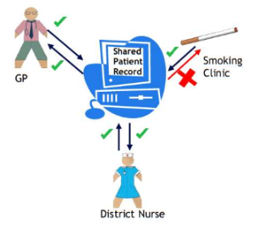
- The GP can share information IN and OUT
- The District Nurse can share IN and OUT
- The Smoking Clinic can only share information OUT but not IN

When you are first or next seen at the care service, you will be asked the following questions:

1. Do you consent to the information that is recorded about you here being made available to other NHS care services that care for you and also use SystmOne?

If you answer YES – clinicians at other services that care for you and use SystmOne will be able to see the information recorded here. For example, a district nurse that visits you would be able to see the data entered by your GP.

If you answer NO – The clinician will be prevented from sharing the information entered here with other services caring for you.

2. Do you consent to allow this care service to view information about you that has been recorded at other services where you also receive care? (You must have separately consented for information to be ‘shared out’ of those services)

If you answer YES – This care service will be able to view information recorded by other NHS Services.
If you answer NO – This care service will not see any information at any other NHS service (even if those services have the consent to share information out).

NOTE: You can still request for individual entries in our patient record to be marked as ‘Private’. These will not be visible at any care service other than the one that recorded the information.

Why is this necessary?

These settings allow you to decide who can see the information on your electronic record. It also allows for jointed up care across different NHS settings which gives the best care and service to you.

NOTE: In some serious situations, for example if you are unconscious, clinicians will be able to access your electronic record without first asking your permission. Use of this is monitored.

DON’T FORGET

These settings apply to any NHS service using SystmOne where you are currently receiving care. You can also change your sharing preference at any time – just speak to a member of staff at this care service.
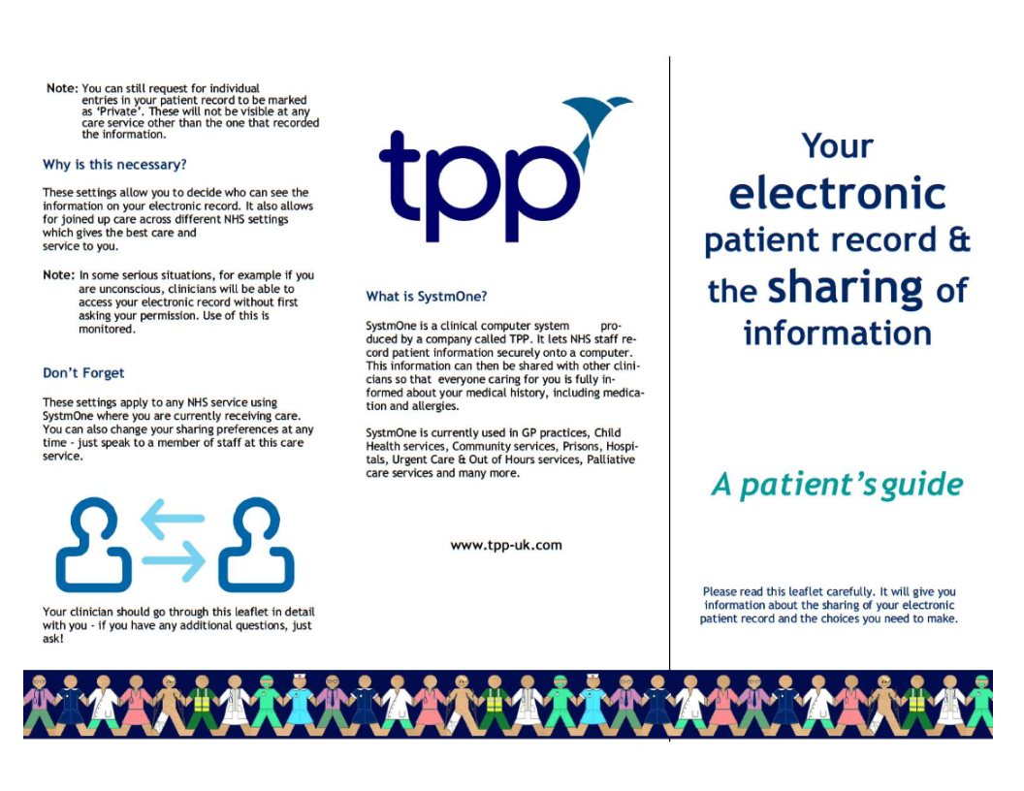
Your clinician should go through this leaflet in detail with you – if you have any additional questions, just ask!

What is SystmOne?

SystmOne is a clinical computer system produced by a company called TPP. It lets NHS staff record patient information securely onto a computer. This information can then be shared with other clinicians so that everyone caring for you is fully informed about your medical history, including medication and allergies.

SystmOne is currently used in GP practices, Child Health Services, Community Services, Prisons, Hospitals, Urgent
Care and Out of Hours services, Palliative care services and many more. www.tpp-uk.com

Your GP practice holds copies of your patient health record electronically and in paper format. Both contain the healthcare information about you that your GP needs including your medical history, medications, allergies, immunisations and vaccinations.  If you have previously registered with a different GP in England, upon registering at this practice your electronic health record will, where possible, be transferred automatically form your previous practice through the use of an NHS system called GP2GP.  Patient benefits  When patients move practices, paper medical records can take weeks to arrive but GP2GP transfers are faster, more reliable and more secure than the existing paper-based method of transferring patient records. This means your new practice will have your full and detailed medical record available in time for your very first appointment. | Frequently asked questions  - What is GP2GP – GP2GP is the technology that transfers your electronic health record directly and securely from your previous GP when you register at this practice.  - Does my old practice need to be using GP2GP for my electronic health record to be transferred electronically? Yes, both practices need to be using GP2GP if they are not, only your paper medial record will be sent and will include a printout of your electronic health record from your previous practice.  - What happens to my paper record? Your paper medical record will also be transferred to this practice. This usually takes about six to eight weeks. In the future when all practices are using GP2GP the need for sending paper records may be reviewed.  - What information will be transferred in my electronic health record? The information contained within your electronic health record at your previous practice will be transferred. This includes information about your medications, allergies, adverse reactions, immunisations and vaccinations laboratory results, diagnoses, medical history and letters from specialists.  - Will my repeat prescriptions be automatically transferred as well? Yes, GP2GP transfers all the information about your medications. Your new GP will review all the medicines you are taking before authorising any repeat prescriptions.  - I am registered as a temporary resident. Will my electronic health record still be transferred electronically? No, if you are registering as a temporary resident your health records remain at your usual practice and not transferred either as paper or via GP2GP. Your temporary practice will contact your registered GP if they require any information.  - Where can I find out more about GP2GP? Our practice staff should be able to answer any queries you may have. You can also read about GP2GP on the Health and Social Care Information Centre website: www.hscic.gov.uk/gp2gp

THE NHS ZERO TOLERANCE POLICY

We operate the NHS Zero Tolerance Policy to safeguard staff and patient welfare. Our Team shall always show due respect and courtesy when dealing with patients.

In turn, we would request Patients to reciprocate the same. No form of aggression, verbal or physical in nature will be tolerated and may result in Patient removal and being reported to the Police.
Your next appointment is:-


Date __________________________________ Time_____________

Date __________________________________ Time_____________

Date __________________________________ Time_____________

Date __________________________________ Time_____________

Text Messaging!

Do you have a mobile phone?

We can contact you by text messaging regarding some test results and send out reminders for appointments.
DNA’s (Did not attend)
Each month we display how many appointments are wasted due to patients not attending their booked appointments. On average we lose 9 hours per week due to patients not informing us they no longer needed their appointments. With over 8,600 patients we are a very busy practice and with patients help we would like to reduce your waiting times for these routine appointments.

Our practice policy is that we will send a letter to a patient who DNA’s their appointment three times without providing any notice of cancellation. If this still continues the practice may remove the patient from the list.

“Please remember to ALWAYS cancel your appointment no later than one hour before your booked time.”

